***Java Assignment Module 1***

1. Reverse a number in java

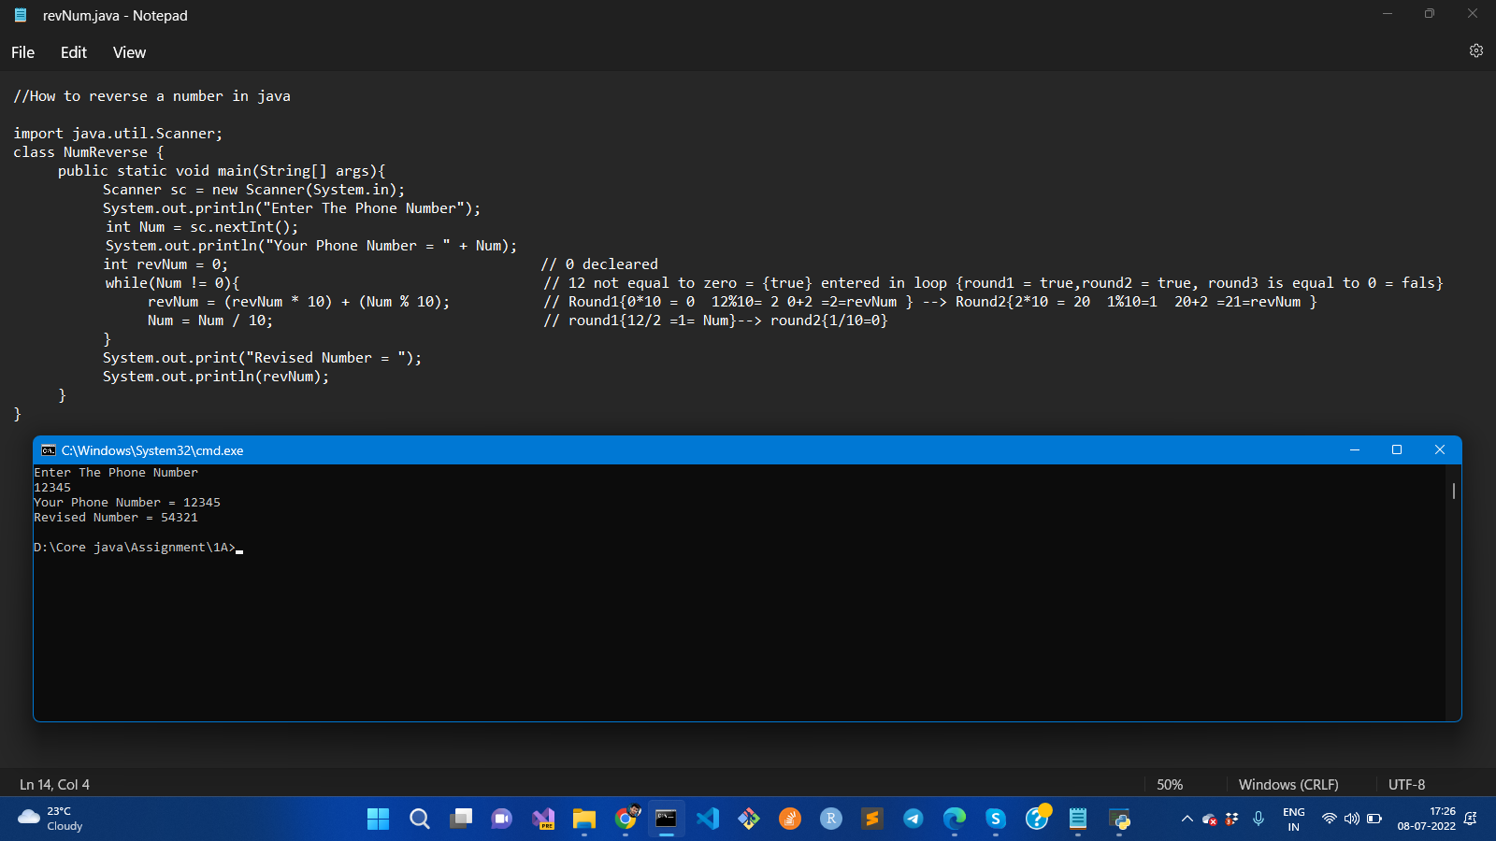

1. Program to check whether the input number is palindrome or not

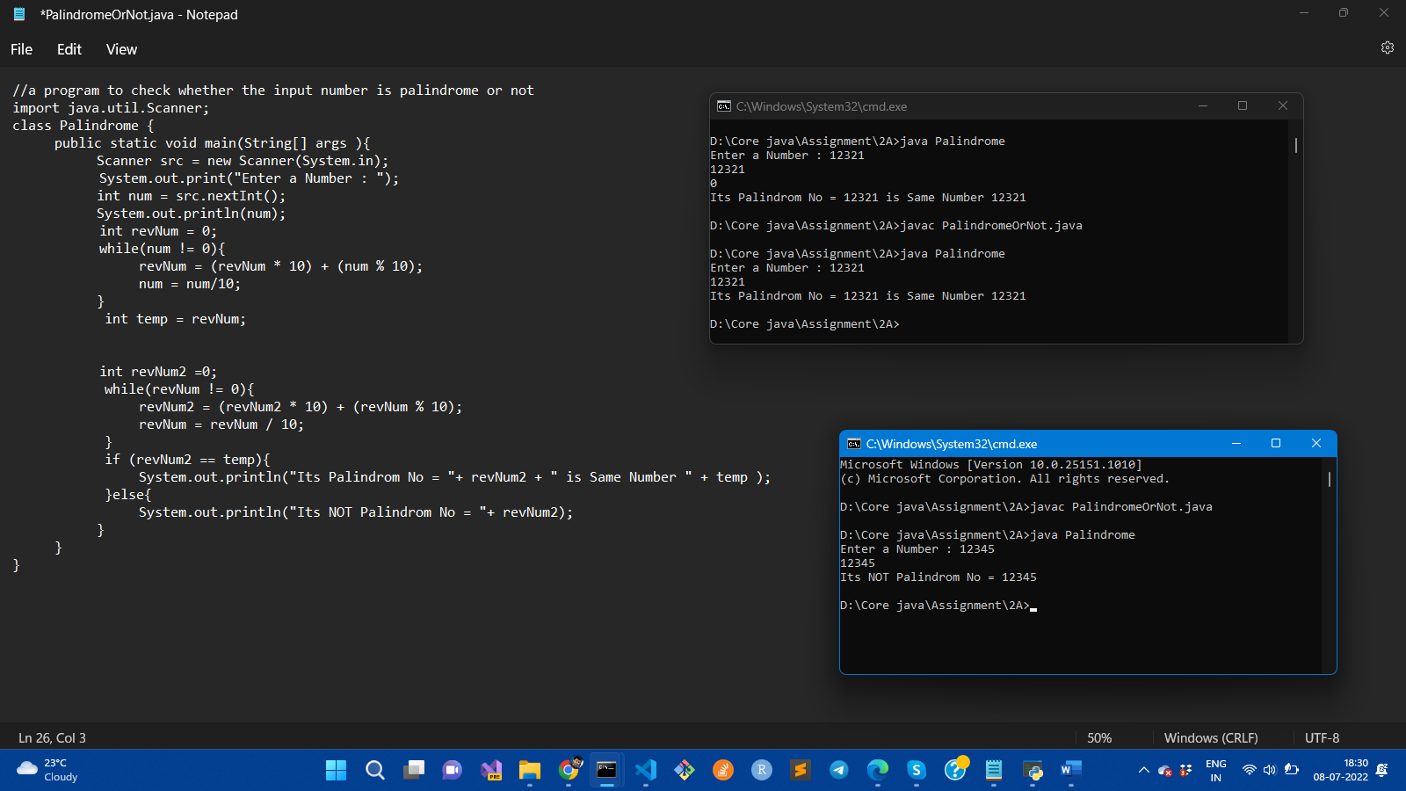

1. Write a java program that takes 5 numbers as input and calculate the average of the number

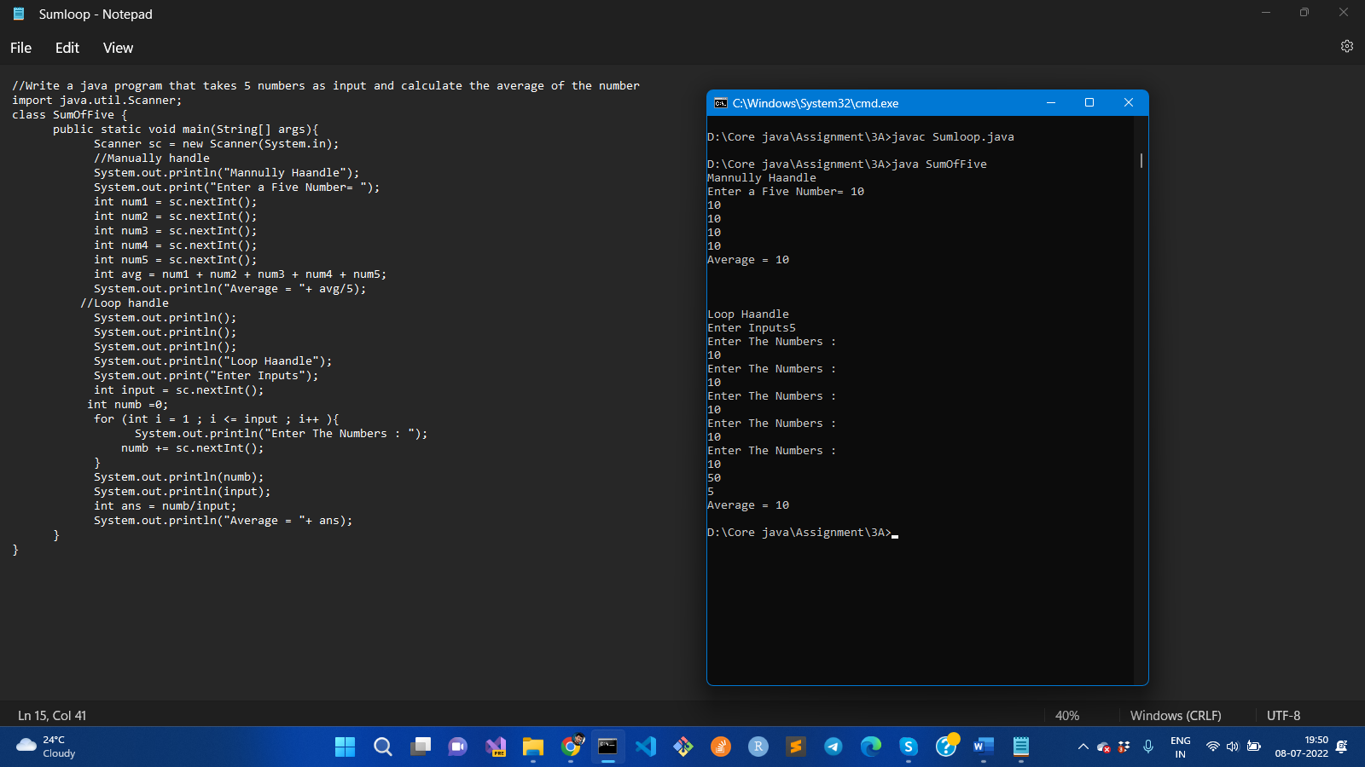

1. Write a java program to swap two numbers without creating third variable

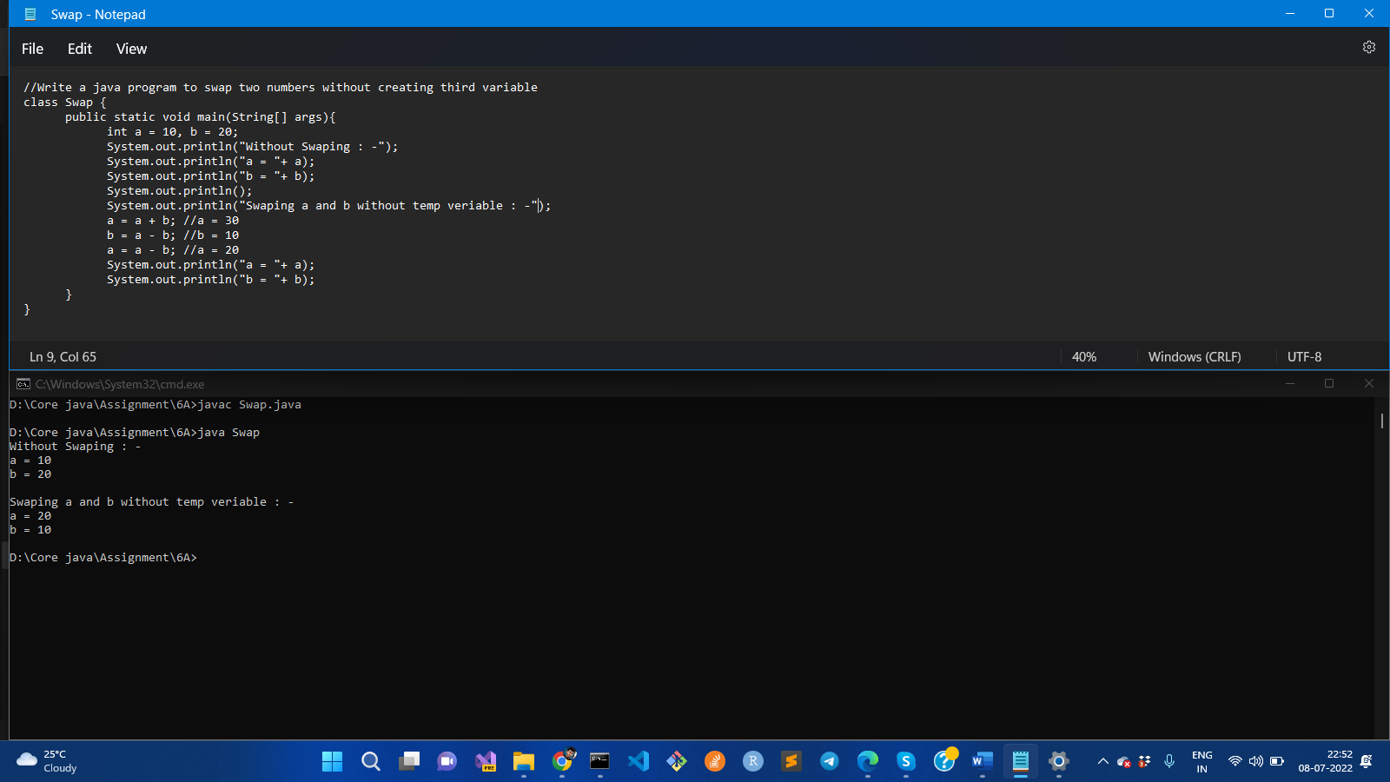

1. Write a program to check whether the input year is Leap year or not

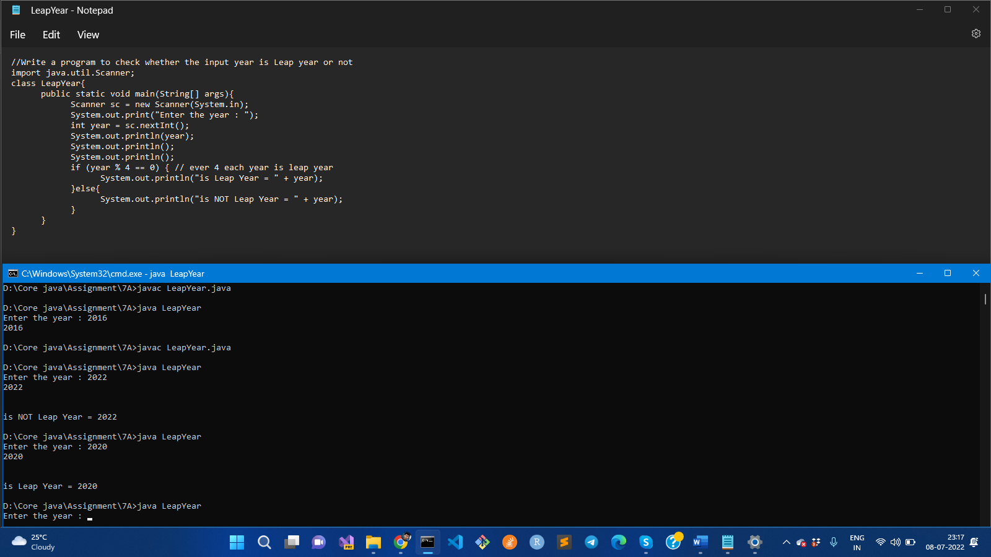

6. How to create a star pyramid pattern using ‘*’ in Java

* * * * * * *

* * * * *

* * *

* *

*

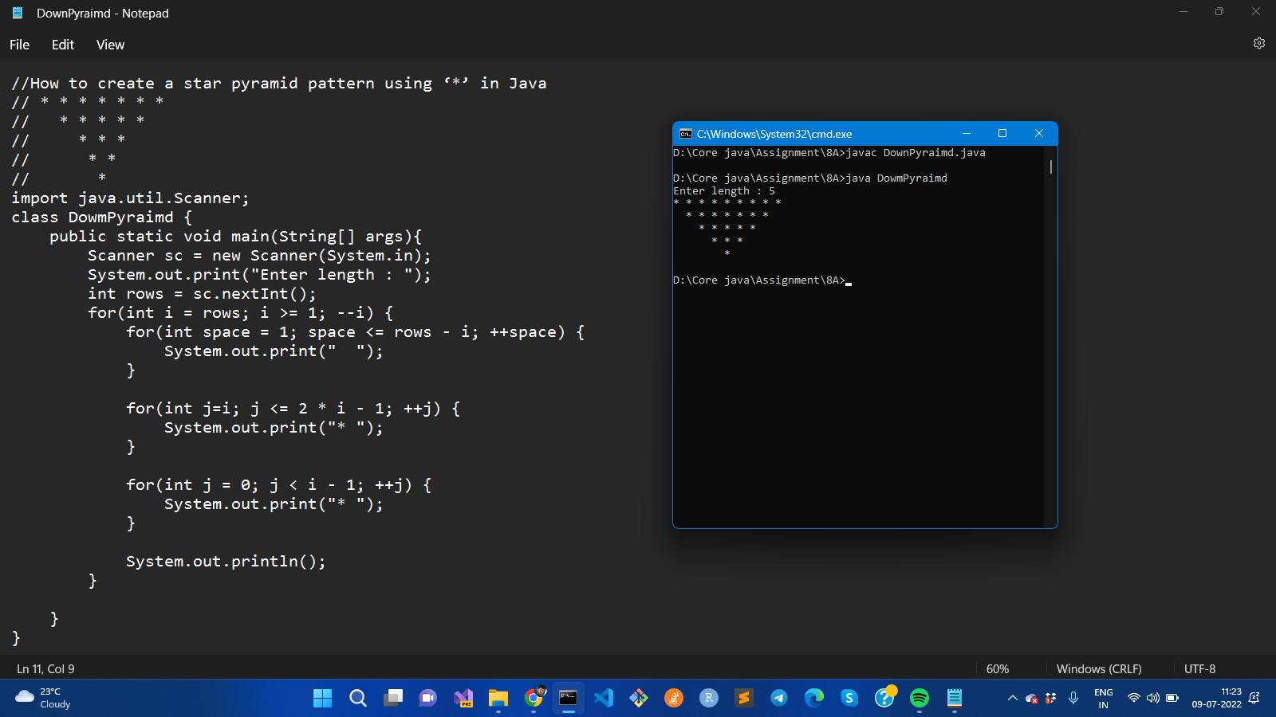

1. Write A Program To Print Inverted Half Pyramid Pattern Using Numbers In Java

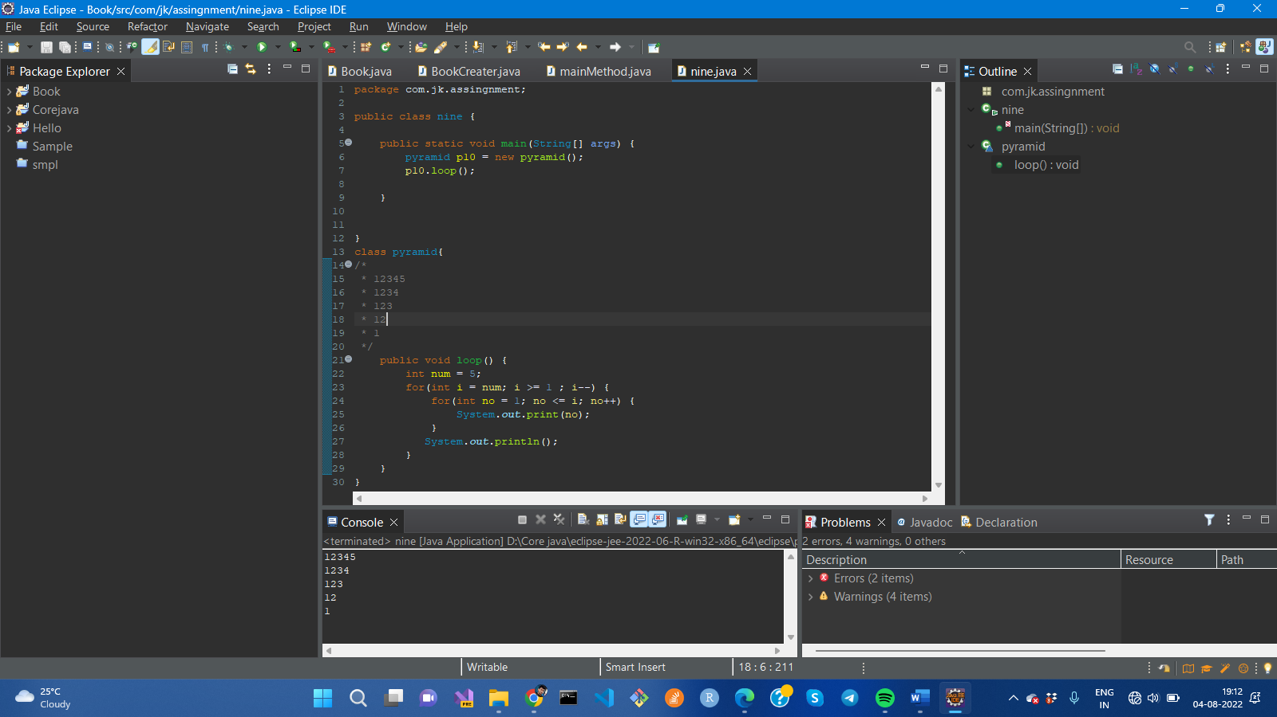

1. Write A Program To Print Hollow Rectangle Using “*” In Java 